Look at pg 462- Read the paragraph. Would you go on this trip? Answer the 2 purple questions on the bottom of the page.

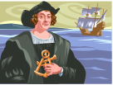 Why did explorers take the challenge?
- After the crusades, people were curious as to the riches they could find in foreign countries, and since demand is high, they will make $$$$$
  - Spices (nutmeg, ginger, cinnamon, salt, pepper)
  - Luxury items from Asia
  - Gold
  - Fountain of youth
- Many were religious and wanted to spread Christianity
  - Missionaries 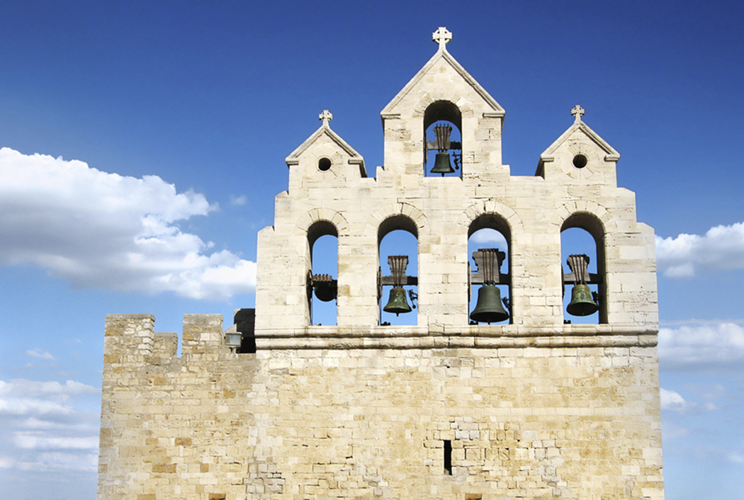 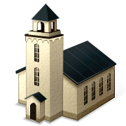
- The over land routes were dangerous due to Muslim and Italian control (pay the toll)
 
- New technology made world travel a new possibility (Pg 465 in your book)
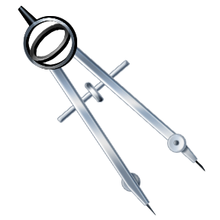
  - Caravel ship with triangular shaped sails
  - Better navigation
  - Astrolabe (to tell how far north or south stars were from the equator)
  - Compass
- GLORY 

As Spain and Portugal were out exploring, they were also ready to fight each other over the new lands over who got control over these areas.
- The Treaty of Tordesillas divided the Atlantic Ocean into an East and West- Portugal got the East half, and Spain got the West half.
SpainPortugal

Discussion:
- As the explorers found new lands, did they actually have “claim” to the lands they were finding?
- How do you think the explorers were greeted in the countries they “conquered”?
- Spain and Portugal began trading with the new areas they found and made an extreme amount of wealth- Was this fair?
~~~~~~~~~~~~~~~~~~~~~~~~~~~~~~~~~~~~~~~~~~~~~~~~~~~

Pg 482- Read the paragraph at the top- Which Side would you choose?
- What risks are involved in supporting the invaders?
- Does the fact that the Aztecs have a similar culture affect your decision?
- What are the advantages and disadvantages of not fighting at all?

Columbus makes the first trek across the Atlantic, and kicked off a wave of many explorers looking to find their fortune in the New World (people lived there)

As explorers found the “New World,” they set up colonies (cities/regions controlled by their home countries) which were responsible for paying tribute (taxes/goods)

Read together about Cortes- pg 485
Read excerpt from speeches given by Montezuma and Cortes.

